Overview of Web - API
A Web API (Web Application Programming Interface) is a framework that allows applications to communicate with each other over the internet using HTTP protocols. It enables data exchange between different software systems, typically in a client-server architecture.
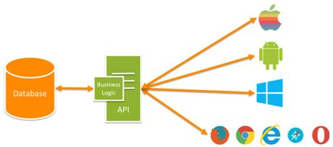
Example of how an API works:
- You want to use a map service to show directions on your website.
- You find a map service that provides an API.
- You sign up for an account with the map service and get an API key.
- You use the API key to make requests to the map service’s servers.
- The map service’s servers respond to your requests with directions.
- You display the directions on your website.

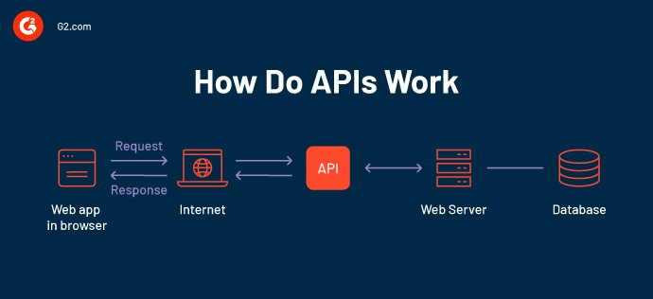
Key Features
- Stateless Communication: Each request from the client to the server is independent.

- Uses HTTP Methods: Common methods include
GET: Retrieve data
POST: Submit data
PUT: Update data
DELETE: Remove data
• Data Format: Most commonly uses JSON or XML for data exchange.
- Platform Independent: Can be accessed by any client (browser, mobile app, etc.) regardless of technology.

Web API in ASP.NET Core:
- Lightweight framework for building RESTful services.
- Easily integrates with Entity Framework for data access.
- Uses Controllers to handle HTTP requests.

Uses HTTP Methods – With Real-World Examples

1. GET – Retrieve data from the server ✅
What it does: Asks the server for information.
Example: You open an online store and view a list of products. Your browser sends a GET request to the server to fetch and display the products.

2. POST – Create a new resource ➕
What it does: Sends new data to the server to be saved.
Example: You fill out a form to add a new product (like a mouse or keyboard). When you submit it, the website sends a POST request to the server to store this new product.

3. PUT – Update an existing resource ♻️
What it does: Replaces or updates existing information on the server.
Example: You go to the product details page and edit the price of a laptop. When you save the changes, a PUT request updates the laptop's price on the server.

4. DELETE – Remove a resource ❌
What it does: Tells the server to delete something.
Example: You decide to remove a product from the store. When you click “Delete,” a DELETE request is sent to the server to remove that specific product.

✅ Advantages:
- Enables cross-platform communication
- Promotes code reuse and modularity
- Makes integration between systems easy, such as mobile apps connecting to a backend service

Real-World Example:

Online Shopping Website Example
- GET – You browse the website to view products.
(Fetch product list from the server)
- POST – An admin adds a new product to the store.
(Send product details to the server to create it)
- PUT – The price of a product is updated.
(Send updated data to the server to modify it)
- DELETE – A discontinued product is removed from the website.
(Tell the server to delete that product)

